Construction RFI Form
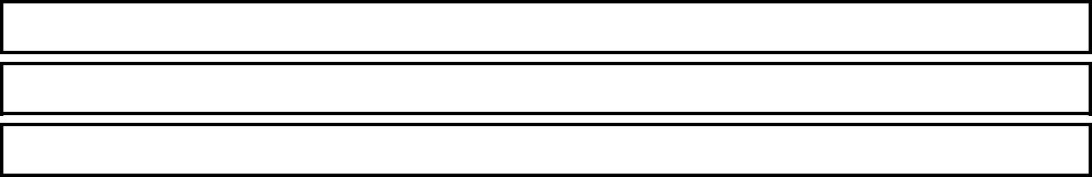

RFI Submission Date: |  | RFI #: |  |  | Urgency
 |  |  |  |  |  | High (1 day)
 |  |  |  |  |  | Med. (2‐4 days)
Question: |  |  |  |  |  | Low (5 days or more)


Set Sheet #'s
Spec. Section #'s Superintendent
Response:


Contract Administrator
Other RFI Responder
RFI Response Date
Instructions:

Fill out form completely, and submit to Contract Administrator via e‐mail. Log RFI's in the RFI log. Submit a separate RFI for each request.

